

Prototype Assembly Instructions
for
iMX8M_HMI_Platform

Version  Status  Date | 1.0  Baselined  24-Oct-2018

Confidentiality Notice
Copyright (c) 2026 eInfochips. - All rights reserved
This document is authored by eInfochips and is eInfochips intellectual property, including the copyrights in all countries in the world. This document is provided under a license to use only with all other rights, including ownership rights, being retained by eInfochips. This file may not be distributed, copied, or reproduced in any manner, electronic or otherwise, without the express written consent of eInfochips.
Contents
1 Document details 3
1.1 Document History 3
1.2 Definition, Acronyms and Abbreviations 3
1.3 References 3
2 introduction 4
3 PCB Assembly Instructions 5
3.1 iMX8M_HMI_Platform (17_00666_01) 5
3.1.1 Stencil Instructions 5
3.1.2 Baking Instructions 5
3.1.2.1 Bare PCB Baking 5
3.1.2.2 Component Baking 5
3.1.3 X-Ray Inspection 6
3.1.4 Manual Assembly 6
3.1.5 Reflow Profile 7
3.1.5.1 Recommendation for Processor (U46) 7
3.1.5.2 Recommendation for LPDDR4 memory (U47) 8
3.1.5.3 Recommendation for Wi-Fi BT Module (U6) 9
3.1.6 Shield Clips assembly guide 9
3.1.7 Impedance measurement Table 10

Document details

Document History

Version | Author |  | Reviewer |  | Approver
Version | Name | Date  (DD-MMM-YYYY) | Name | Date  (DD-MMM-YYYY) | Name | Date  (DD-MMM-YYYY)
Draft 0.1 | Richa Prajapati | 24-Oct-2018 | Anirudha Chougule | 24-Oct-2018
Draft 0.2 | Richa Prajapati | 24-Oct-2018 | Anirudha Chougule | 24-Oct-2018
1.0 | Richa Prajapati | 24-Oct-2018 |  |  | Anirudha Chougule | 24-Oct-2018
Table 1: Document History

Version | Description of Change
Draft 0.1 | Initial Draft Created
Draft 0.2 | Internal review comments implemented
Version 1.0 | Baselined

Definition, Acronyms and Abbreviations
Definition/ Acronym/ Abbreviation | Description
PCB | Printed Circuit Board
HMI | Human Machine Interface
MSL | Moisture Sensitivity Level
LPDDR | Low Power DDR

References

# | Document | Version | Remarks
 | IPC/JEDECJ-STD-033.pdf | B.1

introduction
This document provides prototype-manufacturing instructions for iMX8M_HMI_Platform boards.

This document covers the instructions needed to be given to manufacturing personnel or vendor for PCB assembly.

PCB Assembly Instructions
This section consists of instructions for the assembly of components on printed circuit board(s) of iMX8M_HMI_Platform Board (17_00666_01).

iMX8M_HMI_Platform (17_00666_01)

Stencil Instructions
The following instructions need to be followed while preparing stencil for iMX8M_HMI_Platform board.

1. Use Top and Bottom Solder Paste layer from Gerber data for preparing the stencil.
2. Refer to the special instructions below while preparing the stencil.

Baking Instructions

Bare PCB Baking
Bare PCB needs to be baked for 24 hours at 90° Celsius.

Component Baking
Components need to be baked as per MSL Rating & JEDEC Standard Device Recommendation. If discrete components are not exposed to environment, then there is no need to bake these components.

Refer below table for MSL Rating & Baking Time of all the chipsets used in iMX8M_HMI Board:

Parts | MSL rating as per datasheet | Baking Time  In Hrs. | Baking Temperature | Remarks
ADP1710AUJZ-R7 (U4,U49) | 1 | 12h | 60C
CYUSB3304-68LTXI (U5) | 3 | 9h | 125C | Thickness <=1.4 mm
W25Q256JWPIQ  (U11) | 1 | 12h | 60C | MSL Assumed
MT53B512M32D2NP-062 WT (U47) | 3 | 9h | 125C
MIMX8MQ6CVAHZAA (U46) | 3 | 43h | 125C | Thickness >=2mm
KSZ9031RNXIC-TR (U58) | 3 | 9h | 125C
ADV7535BCBZ-RL (U18) | 3 | 9h | 125C | Thickness <=1.4 mm
LBEE5HY1MW-TEMP(U6) | 3 | 24h | 125C | As per datasheet
LT8642SEV#PBF  (U15,U57) | 3 | 9h | 125C | Thickness <=1.4 mm
FJX3014RTF  (U1,U22,U23,U24,U27,U28) | 1 | 12h | 60C
ECMF02-4CMX8  (U2,U30,U31) | 1 | 12h | 60C
MC34PF4210A1ES(U7) | 3 | 9h | 125C
74LVC2G125(U8) | 1 | 12h | 60C
ADM1816-20ARTZ-RL7(U9,U50) | 1 | 12h | 60C
A7101CHTK2/T0BC2VJ (U3) | 1 | 12h | 60C
MCP6561T-E/LT(U10) | 1 | 12h | 60C
FSA644UCX(U12) | 1 | 12h | 60C
MGM111A256V2(U13) | 3 | 27h | 125C | Thickness ≤2.0 mm
NLSX5014MUTAG  (U14,U52,U56,U60) | 1 | 12h | 60C
ADG3308BCPZ-REEL7(U16) | 3 | 9h | 125C | Thickness <=1.4 mm
MCP2515T-I/ML(U17) | 1 | 12h | 60C
TJA1052IT/2Y(U19) | 3 | 48h | 125C | Thickness ≤4.5 mm
SP5003-04TTG  (U20,U21,U32,U33,U34,U35, U36,U37,U41,U42,U43,U44, U45) | 1 | 12h | 60C
MIC2009YML-TR  (U25,U26,U29) | 1 | 12h | 60C
PCA9306FMUTCG(U40) | 1 | 12h | 60C
CP2105-F01-GMR(U48) | 1 | 12h | 60C
ADP5014ACPZ-R7(U51) | 3 | 9h | 125C | Thickness <=1.4 mm
ADM6315-26D3ARTZR7(U53) | 1 | 12h | 60C
ADAU1361BCPZ-R7(U54) | 3 | 9h | 125C | Thickness <=1.4 mm
M24256-DFMC6TG(U55) | 1 | 12h | 60C
ECMF04-4HSWM10  (U38,U39) | 1 | 12h | 60C
ADUM5020-5BRWZ(U59) | 3 | 48h | 125C | Thickness ≤4.5 mm

X-Ray Inspection
X-ray Inspection should be done for all the BGA’s in the board.

- X-Ray inspection should be used to verify good solder joint formation
- 2-D X-Ray is used to detect shorts, through top-down view

Manual Assembly

Refer below list of through-hole components used in iMX8M_HMI_Platform Board for Manual Assembly:

Mfg. Part# | Ref-des | Description
PJ-041H | J14 | DC Jack Connector
10029449-111RLF | J2,J15 | HDMI Connectors
2134536-2 | J1 | USB connector - micro AB 2.0
1932258-1 | J3,J4 | USB 3.0 Type A Connectors
20021111-00010T4LF | J9,J11 | JTAG Header
87224-2 | J12 | Header
1-2301994-2 | J13 | Ethernet connector
440055-2 | J16 | CAN Connector
87224-1 | J18 | GND Header

Reflow Profile

Recommendation for Processor (U46)

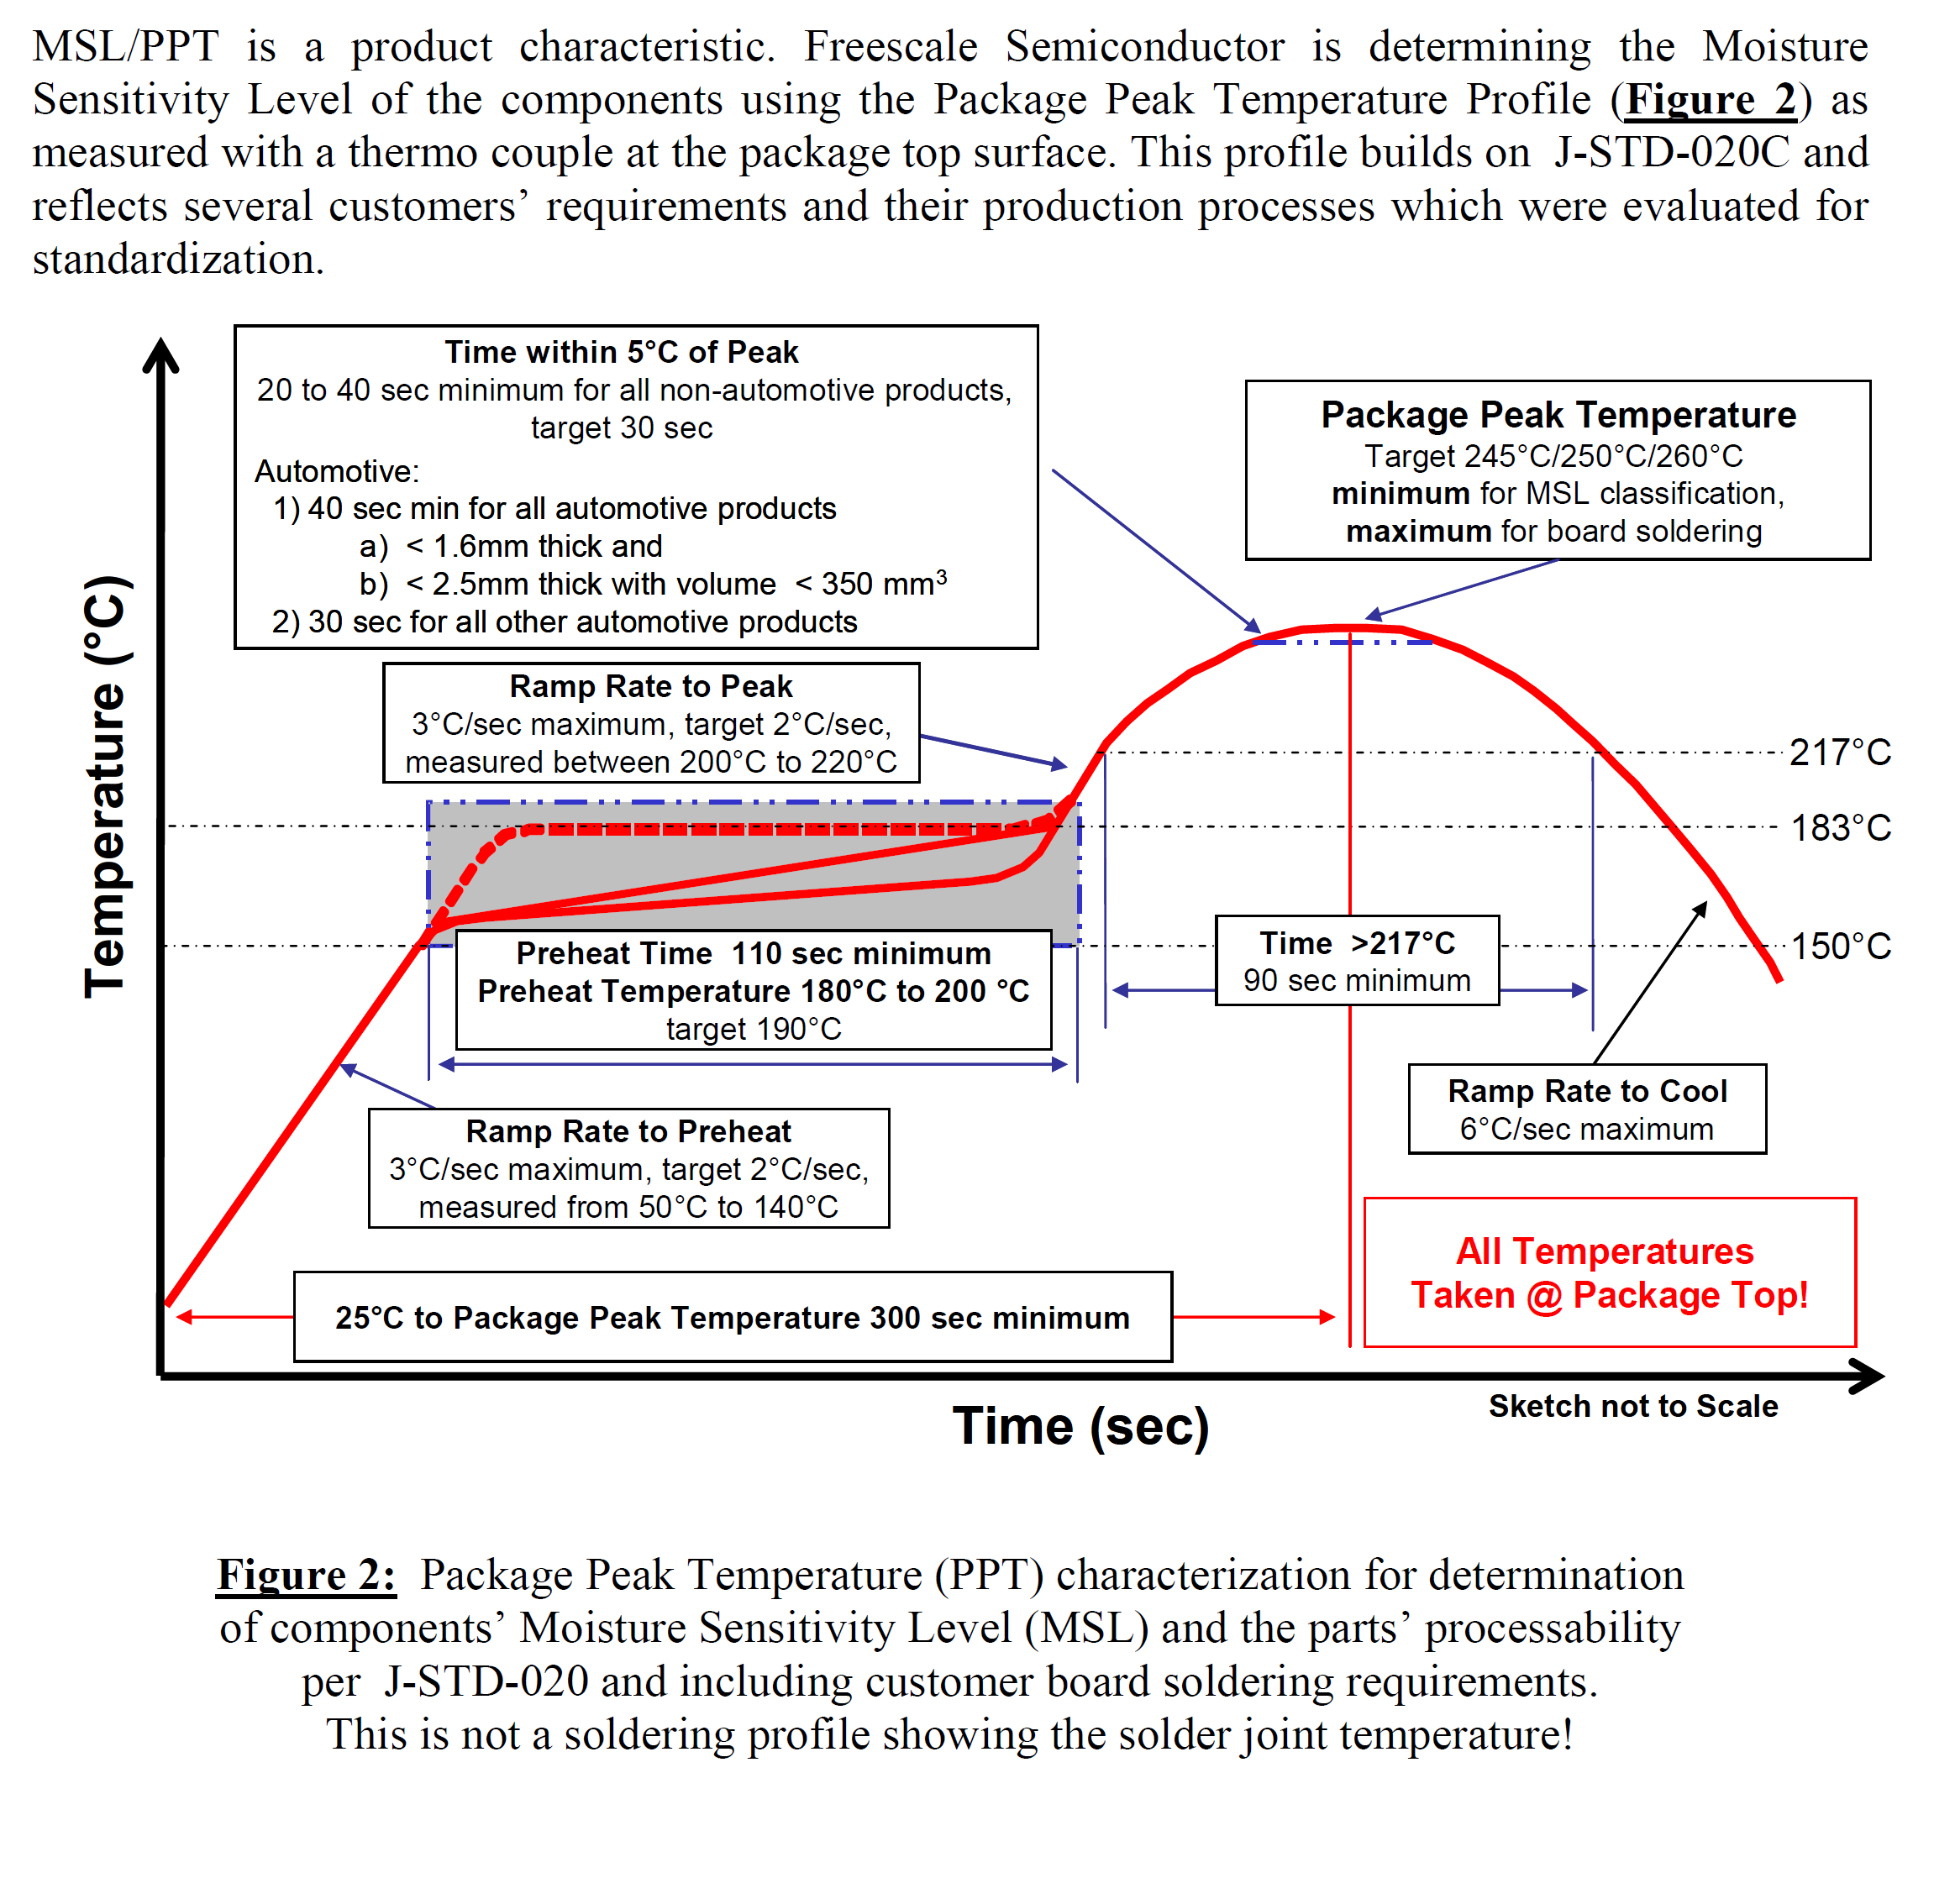’
Figure 1: Reflow Profile of Processor

Recommendation for LPDDR4 memory (U47)
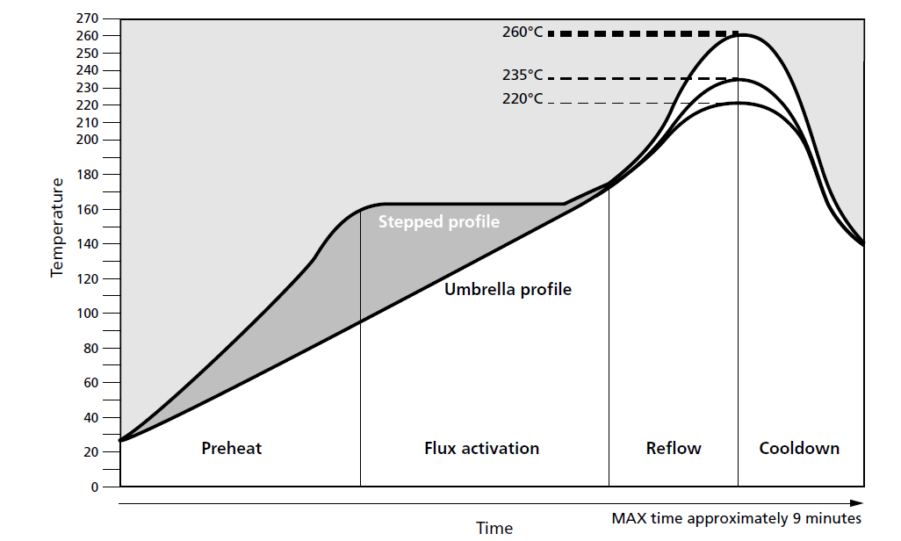

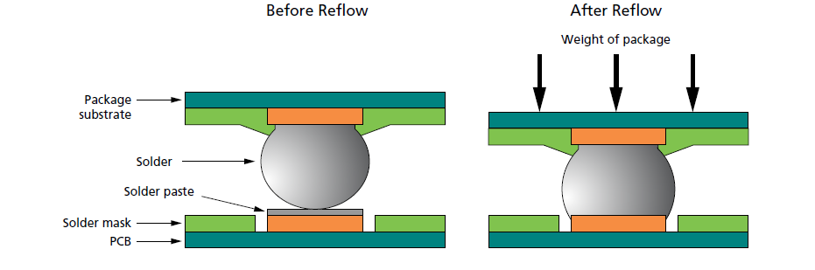

Figure 2: Reflow Profile of Memory

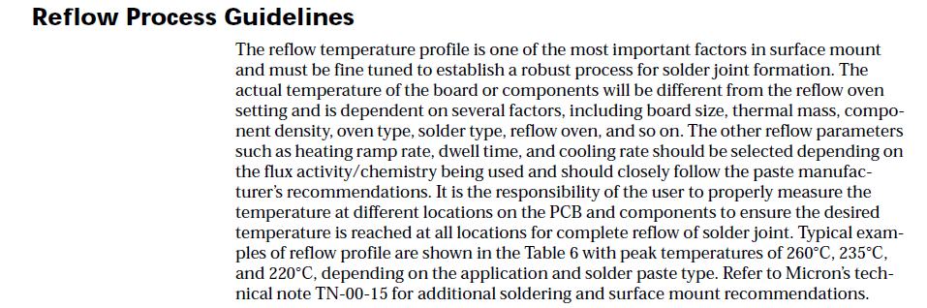

Recommendation for Wi-Fi BT Module (U6)

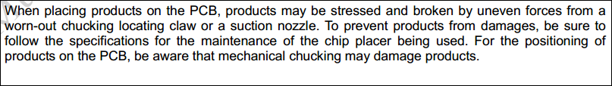

Soldering Conditions:

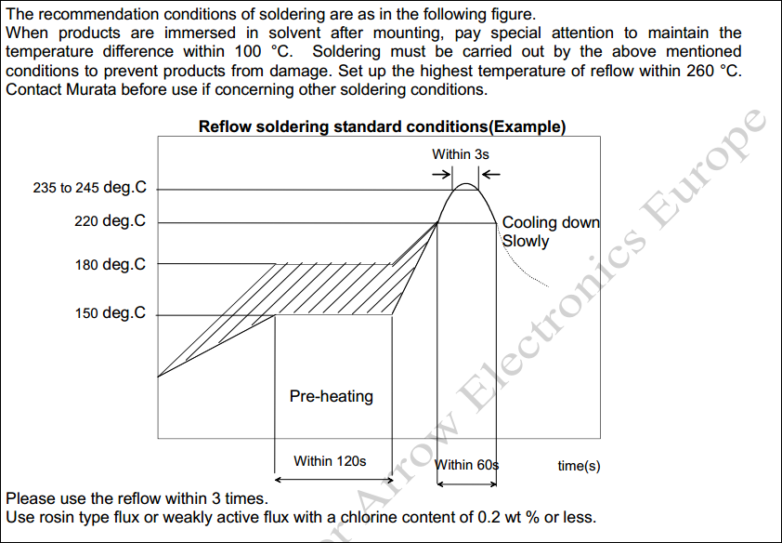

Shield Clips assembly guide
- Kindly make sure that shield clips should not have copper filled inside
- Mounting of Shield clips should be proper so that linear clips can be aligned

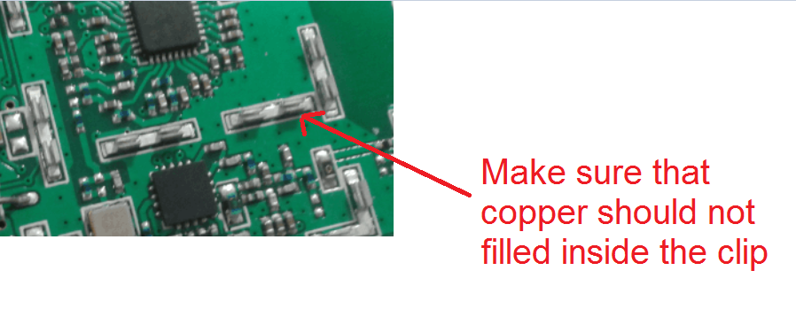

Impedance measurement Table
After assembly, kindly measure the impedance as per below table and provide the report with actual values of impedance measurement.

Power Supply Rail | Measurement Location | Expected Resistance Value  (E= ohm, K= kilo ohm, M= mega ohm)
VCC_12V0 | TP16 & J18 | >1K
DCDC_3V3 | TP34 & J18 | >1K
VCC_5V | TP31 & J18 | >1K
VDD_GPU_1V0 | C214 | >100E
VDD_VPU_1V0 | C210 | >100E
NVCC_DRAM_1V1 | TP1 & J18 | >100E
VDD_DRAM_1V0 | TP17 & J18 | >100E
VDD_1V8 | C137 | >1K
VCAM_1V5 | R76 & J18 | >1K
VDD_PHY_0V9 | C125 | >100E
VDD_PHY_1V8 | C361 | >1K
VDDA_1V8 | C58 | >1K
VDD_PHY_3V3 | C27 | >1K
VCAM_2V8 | C26 | >1K
VREFDDR | C33 | >100E
VDD_SNVS_0V9 | C392 | >1K
VDD_SOC_0V9 | TP26 & J18 | >100E
VDD_ARM_1V0 | TP24 & J18 | >100E
VCC_1V8_EXT | TP33 & J18 | >1K
VCC_1V2 | TP32 & J18 | >1K

